**Embedded System LAB Practice:**

1: Write a PWM program to gradually increase the LED contrast and gradually decrease. Once one LED contrast gradually deceased anther colour LED do the same. (Repeat it same for all onboard LED on TM4C123GH). (Also try to create different duty cycle PWM using LOAD register).

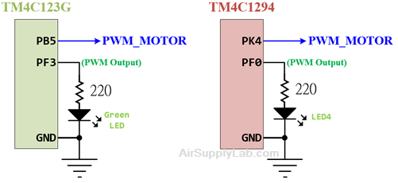

2. Write an Analog Input Based Control to glow each LED at different threshold of Analog Input Value.

Mc sensor via adc.png

In this program, you have to connect one potentiometer and provide the variable voltage to the analog GPIO port and control the LEDs ON and OFF at different threshold of Analog voltage

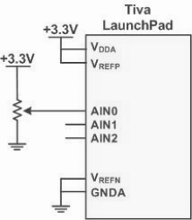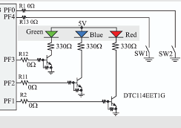

3. Write a PWM Control to control the motor speed by using the PWM signal

Add onboard two switches, SW1 and SW2, to the project.

* SW1 is used for changing the motor speed - when the user presses the SW1, the duty cycle changes from 0%, 30%, 60% to 100%, and then back to 0%.
* SW2 is used for changing the motor direction - when the user presses the SW2, change the motor rotation direction. (Do not change the rotation direction if the duty cycle is 0%)

